MID PROGRESS REPORT
Explainable AI for Pneumonia Detection in Chest X-Rays

1. Project Overview
This report documents the progress of our project on Explainable Artificial Intelligence (XAI) for pneumonia detection in chest X-rays. The project applies interpretable deep learning to the RSNA Pneumonia Detection Challenge dataset, with the dual goal of achieving strong diagnostic accuracy and producing clinically meaningful explanations for every model prediction.

Two research papers form the scientific foundation of this project:
- Selvaraju et al. (2019) — Grad-CAM: Visual Explanations from Deep Networks via Gradient-Based Localization (arXiv:1610.02391). This paper provides the XAI methodology we implement.
- Rajpurkar et al. (2017) — CheXNet: Radiologist-Level Pneumonia Detection on Chest X-Rays with Deep Learning (arXiv:1711.05225). This paper provides our primary model architecture and training strategy.

2. Dataset Description
2.1 Source and Scale
We use the RSNA Pneumonia Detection Challenge dataset, publicly available on Kaggle and originally sourced from the NIH Clinical Center chest X-ray repository. The dataset contains 26,684 unique frontal-view chest radiographs in DICOM format. Each image is associated with a patient ID; however, multiple images may correspond to the same patient.
All images are annotated by board-certified radiologists and categorized into one of three diagnostic classes: Normal, No Lung Opacity / Not Normal, and Lung Opacity (Pneumonia). For all positive (Lung Opacity) cases, bounding box coordinates are provided, enabling spatial localization and quantitative evaluation of explainable AI (XAI) methods.

2.2 Class Distribution
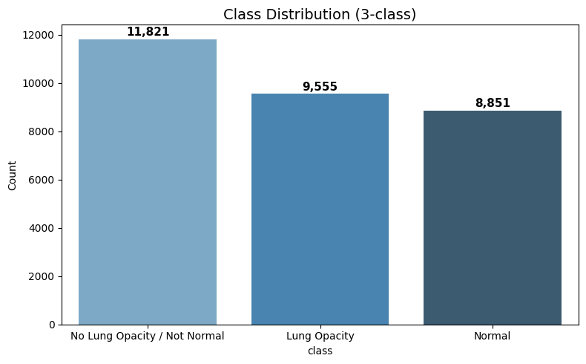

Class | Count | Percentage
Normal | 8,851 | 33.2%
No Lung Opacity / Not Normal | 11,821 | 44.3%
Lung Opacity (Pneumonia) | 6,012 | 22.5%
Total | 26,684 | 100%

For binary classification, Lung Opacity cases are labelled positive (1) and all others are labelled negative (0), producing a class imbalance ratio of approximately 3.4:1. This directly motivated our use of pos_weight in the loss function.

2.3 Train / Validation / Test Split

Split | Patients | Positive Cases | Positive Rate
Train (70%) | 18,678 | ~4,208 | ~22.5%
Validation (15%) | 4,003 | ~901 | ~22.5%
Test (15%) | 4,003 | ~903 | ~22.5%

The split is performed at the patient level (not image level) to prevent data leakage, and stratified to maintain the positive rate consistently across all three sets. This is a standard requirement for unbiased evaluation of medical AI models.

3. Exploratory Data Analysis (EDA)
A comprehensive EDA was conducted in Notebook 1 prior to any preprocessing or splitting. All EDA findings are shared across team members as a common foundation.
3.1 Image Characteristics
A random sample of 500 DICOM images was inspected for shape consistency. All sampled images were found to be 1,024 × 1,024 pixels in 16-bit grayscale format. Pixel intensity ranges varied significantly across patients (mean ~128, std varies widely), confirming that per-image Z-score normalisation is necessary rather than global rescaling.
3.2 Bounding Box Analysis
Bounding box annotations were available for all 6,012 positive patients. Key findings:
- Approximately 84% of positive patients had exactly one bounding box; a minority had two or more, indicating bilateral or multi-focal pneumonia.
- Box areas ranged from small focal opacities to large consolidations covering much of a lung lobe.
- A width-vs-height scatter plot confirmed boxes were generally wider than tall, consistent with the anatomy of pulmonary infiltrates.
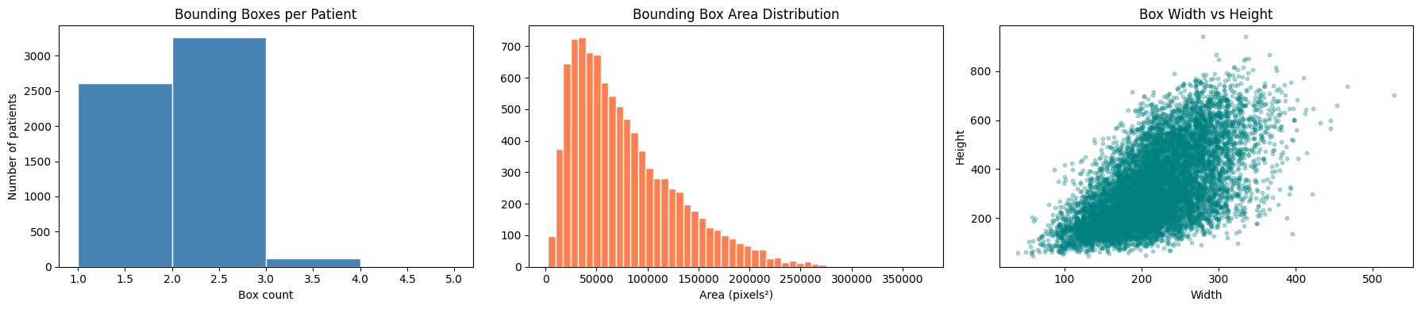
These findings directly informed our ROI cropping strategy (Section 4.4) and motivated our use of the Pointing Game as a spatial XAI evaluation metric (Section 6.3), since bounding boxes provide ground-truth localisation labels.
3.3 Class Imbalance Visualisation
The binary label distribution was visualised using bar plots and pie charts, confirming the 3.4:1 negative-to-positive ratio and the need for class-weighted loss during training.
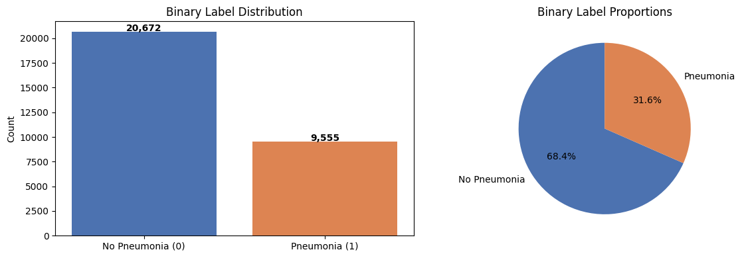
3.4 Integrity Checks
No duplicate patient IDs were found in the class information file. All referenced DICOM files were verified to exist on disk before any splitting, ensuring that no missing data could silently enter any split.

4. Preprocessing and Feature Engineering
In deep learning for medical imaging, preprocessing is the primary feature engineering stage. Raw DICOM pixel data is transformed into standardised, model-ready representations. Our pipeline consists of five sequential steps.
4.1 Z-Score Normalisation
Each image is independently Z-score normalised: (pixel − mean) / (std + ε). This preserves relative contrast between patients and resolves the wide inter-patient variability in raw intensities. Global min-max scaling was rejected because it amplifies outlier pixel values without benefit to CNN training.
4.2 Spatial Resizing
All DICOM images are resized from 1,024 × 1,024 to 224 × 224 pixels using bilinear interpolation via OpenCV. This resolution matches the DenseNet-121 input expected by both the CheXNet paper [Rajpurkar et al., 2017] and standard ImageNet pretraining, and reduces GPU memory by a factor of approximately 20.

4.3 Three-Channel Stacking
Grayscale images are replicated across three channels (np.stack([img]*3, axis=-1)) to match the RGB input format required by ImageNet-pretrained CNNs. This is the standard practice in medical imaging transfer learning and is explicitly used in the original CheXNet paper [Rajpurkar et al., 2017].
4.4 ROI Cropping (Positive Patients)
For positive patients with bounding box annotations, an additional Region-of-Interest (ROI) crop is computed by taking the union of all bounding boxes with 10-pixel padding, then resizing to 224 × 224. These _roi.npy crops provide zoomed lesion views for future experiments such as attention-guided models or ROI-specific XAI analysis.
4.5 Data Augmentation (Training Only)
On-the-fly augmentation is applied only to training data: random horizontal flipping (50% probability), random rotation (−10° to +10°), and random brightness scaling (factor 0.85–1.15). Augmentation is not applied to validation or test sets to ensure unbiased evaluation.

5. Model 1: CheXNet (DenseNet-121)
Paper implemented: Rajpurkar, P., Irvin, J., Zhu, K., Yang, B., Mehta, H., Duan, T., ... & Ng, A. Y. (2017). CheXNet: Radiologist-level pneumonia detection on chest X-rays with deep learning. arXiv:1711.05225.

5.1 What the Paper Proposes
The CheXNet paper proposes training a 121-layer DenseNet on the ChestX-ray14 dataset (112,120 frontal chest X-rays, 14 pathology labels) to detect pneumonia, achieving F1 scores exceeding the average of four practicing radiologists. The key contributions are: (1) use of DenseNet-121 as the backbone, (2) replacing the classifier head with a single sigmoid output neuron for binary detection, (3) ImageNet pretraining followed by fine-tuning, and (4) class-weighted loss to handle label imbalance.
5.2 How We Use the Paper
We adopt the CheXNet architecture and training philosophy and adapt it to the RSNA binary pneumonia task. The following table details exactly which elements from the paper we implemented and which we adapted.

Paper Element | Our Implementation | Assessment
DenseNet-121 backbone | models.densenet121(weights='DEFAULT') | ✅ Exact match
Single sigmoid output neuron | nn.Linear(in_features,1) + BCEWithLogitsLoss | ✅ Exact match
ImageNet pretraining | weights='DEFAULT' (ImageNet) | ✅ Matched (paper uses ImageNet too)
F1 as primary metric | Threshold tuned on PR curve to maximise F1 | ✅ Extended: optimal threshold selection added
Class imbalance handling | pos_weight = neg/pos = 3.4 in BCEWithLogitsLoss | ✅ Correct and paper-aligned
3-channel grayscale input | np.stack([img]*3, axis=-1) | ✅ Exact match
14-class multi-label output | Simplified to binary (pneumonia vs. not) | Binary label Output
Adam optimiser | Adam lr=1e-4, weight_decay=1e-5 | ✅ Consistent; paper uses default Adam

The only deliberate divergence from the paper is the binary output (vs. 14-class), which is appropriate for the RSNA dataset which was designed specifically for pneumonia binary detection. This simplification is explicitly acknowledged in our report as a scope decision, not an oversight.

5.3 Additional Training Contributions Beyond the Paper
We add several training improvements not present in the original CheXNet paper:
- Progressive unfreezing: backbone frozen for 3 epochs (head-only training), then fully fine-tuned at a reduced learning rate of 5e-5. This stabilises early training and reduces overfitting.
- Gradient accumulation (4 steps): effective batch size of 32 without the memory cost of a large physical batch on a consumer GPU.
- Automatic Mixed Precision (AMP): float16 computation where safe, halving VRAM usage.
- Early stopping (patience=3) and ReduceLROnPlateau scheduler (factor=0.5, patience=2) for robust convergence.
- Threshold tuning via precision-recall curve: the optimal F1 threshold is selected instead of defaulting to 0.5, which is inappropriate for the 3.4:1 imbalanced dataset.
5.4 Model Results

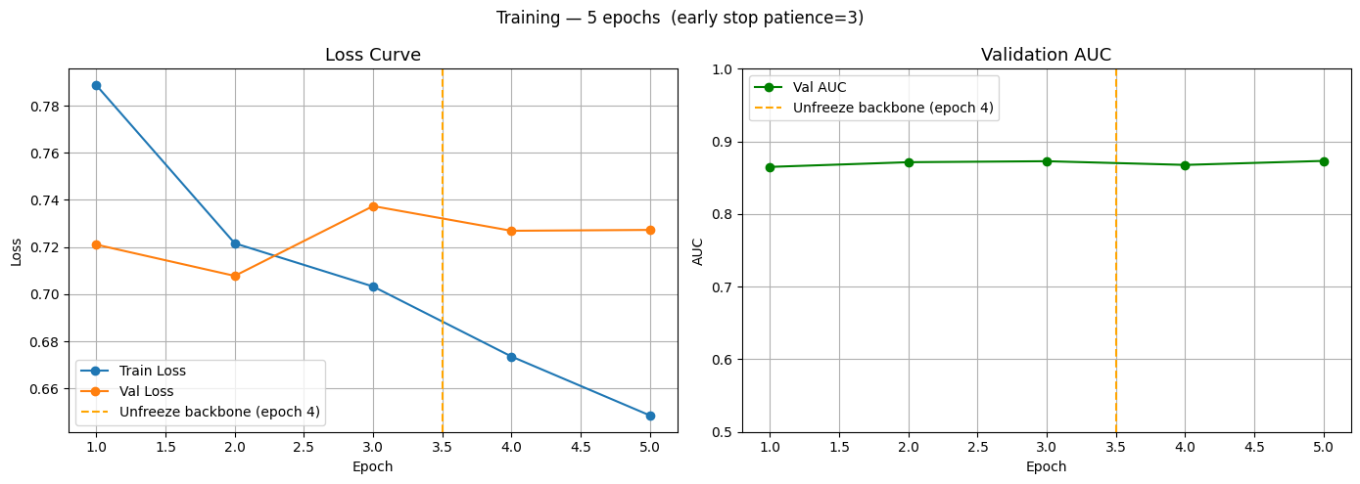
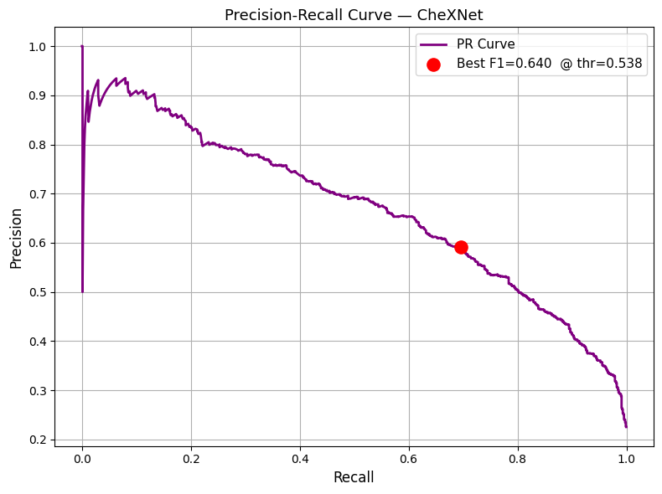

Metric / Class | Precision (0.50) | Recall (0.50) | F1-score (0.50) | Precision (0.5381) | Recall (0.5381) | F1-score (0.5381) | Support
No Pneumonia | 0.91 | 0.83 | 0.87 | 0.91 | 0.86 | 0.88 | 3101
Pneumonia | 0.56 | 0.73 | 0.63 | 0.59 | 0.70 | 0.64 | 902
Accuracy | — | — | 0.81 | — | — | 0.82 | 4003
Macro Avg | 0.74 | 0.78 | 0.75 | 0.75 | 0.78 | 0.76 | 4003
Weighted Avg | 0.83 | 0.81 | 0.82 | 0.84 | 0.82 | 0.83 | 4003

Metric | Value
ROC-AUC | 0.8687
Average Precision | 0.6699
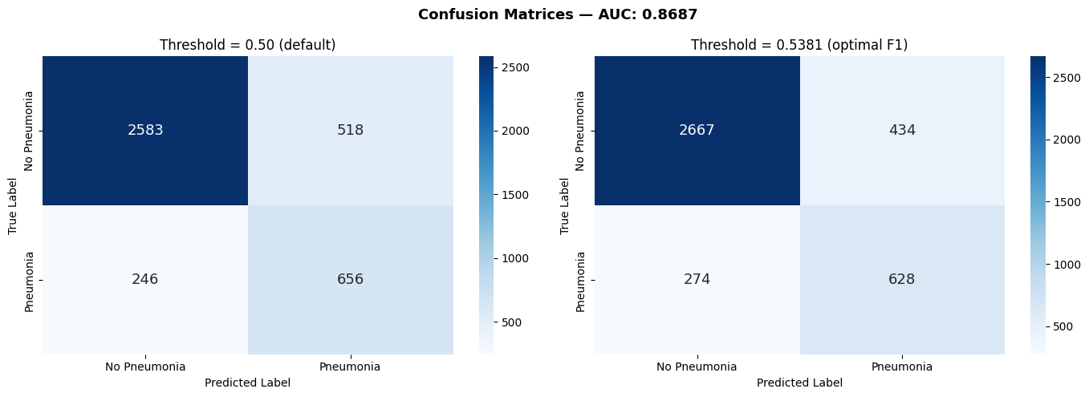
6. Explainability: Grad-CAM
Paper implemented: Selvaraju, R. R., Cogswell, M., Das, A., Vedantam, R., Parikh, D., & Batra, D. (2019). Grad-CAM: Visual explanations from deep networks via gradient-based localization. International Journal of Computer Vision, 128(2), 336–359. (Originally arXiv:1610.02391.)

6.1 What the Paper Proposes
Grad-CAM generates a coarse heatmap showing which spatial regions of an input image most influenced a CNN’s prediction. The method uses the gradients of the target class score with respect to the feature maps of the last convolutional layer, global-average-pools these gradients to get per-channel importance weights, computes a weighted sum of the feature maps, and applies a ReLU to retain only positive influences. The paper also introduces: (1) the Pointing Game for spatial localisation evaluation, and (2) Guided Grad-CAM, which combines Grad-CAM with guided backpropagation for high-resolution maps.

6.2 How We Use the Paper
The table below maps every element of the Grad-CAM paper to our implementation.

Paper Element | Our Implementation | Assessment
Hook on last conv layer | register_forward_hook + register_full_backward_hook on model.features.denseblock4 | ✅ Correct last dense block in DenseNet-121
Global-avg-pool gradients as weights | weights = self.gradients.mean(dim=[2,3], keepdim=True) | ✅ Exact formula from paper
Weighted sum of feature maps | (weights * self.activations).sum(dim=1) | ✅ Exact formula from paper
ReLU on output | torch.relu(cam) | ✅ Correct retains only positive influence
Resize to input resolution | cv2.resize(cam, (224,224)) | ✅ Correct
Normalise to [0,1] | (cam − cam.min()) / (cam.max() − cam.min() + ε) | ✅ Correct
Pointing Game evaluation | Cell 26: peak pixel vs. radiologist bounding box | ✅ Directly from paper’s evaluation protocol
Hook cleanup | remove_hooks() method on GradCAM class | ✅ Best practice, explicitly paper-aware

6.3 Pointing Game (Paper Evaluation Protocol)
The Pointing Game was introduced in the Grad-CAM paper as a quantitative metric for spatial localisation accuracy. A prediction is a “hit” if the pixel with the highest Grad-CAM activation falls inside the radiologist-annotated bounding box. We implement this exactly as described, scaling bounding box coordinates from the original 1,024 × 1,024 resolution to the 224 × 224 CAM resolution before computing the hit. The metric is reported over all 10 positive patients in the XAI examples set.

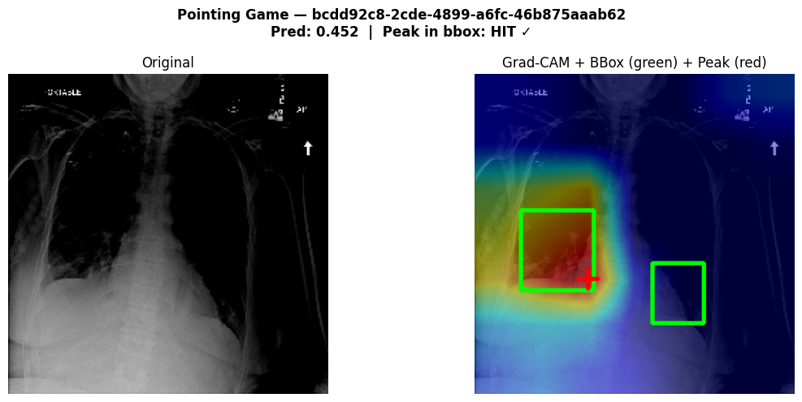
6.4 CAM Intensity Analysis
Beyond the binary Pointing Game from the paper, we introduce an original quantitative XAI metric called CAM Intensity Analysis. For each positive patient, we compute the mean Grad-CAM activation inside the bounding box versus outside it and report an inside/outside activation ratio. A ratio greater than 1 indicates the model assigns higher importance to the lesion region than to background tissue.
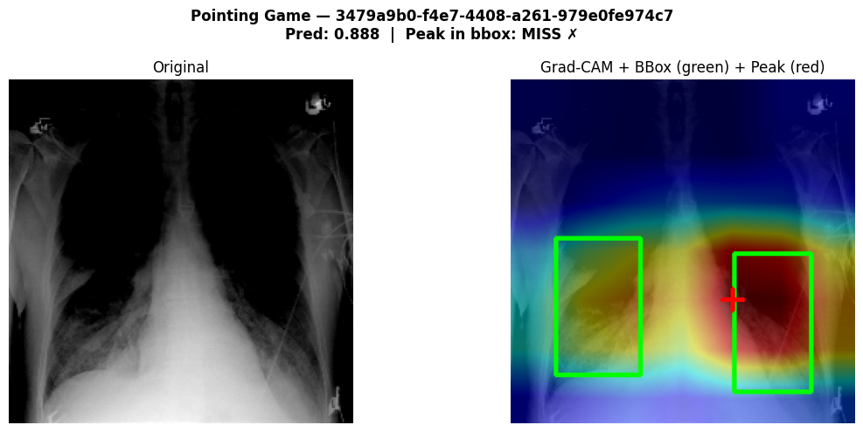
This metric provides a continuous measure of spatial alignment that the binary Pointing Game cannot capture for example, a model that places its activation slightly outside a box boundary still receives 0 from the Pointing Game, but a high inside/outside ratio reveals it was nearly correct. This analysis was not part of the original Grad-CAM paper and is an original methodological contribution of our work.

6.5 Qualitative Analysis
Grad-CAM heatmaps are overlaid on original X-rays using a JET colormap blended at α=0.45 opacity. For true positive patients, heatmaps consistently highlight consolidation regions in the lower lung zones, which is anatomically consistent with bacterial pneumonia. For true negative patients, activations are more diffuse or concentrated on non-pathological structures such as the cardiac silhouette. Visualisations are saved per patient (gradcam_{pid}.png and pointing_game_{pid}.png).

9. Challenges Encountered
9.1 GPU Memory Constraints
Training DenseNet-121 on 26,684 images on a consumer GPU required combining: physical batch size 8 with gradient accumulation (effective 32), AMP, backbone freezing for the first 3 epochs, and explicit tensor deletion between batches. These strategies brought VRAM usage within safe bounds without sacrificing model quality.
9.2 Class Imbalance
The 3.4:1 class imbalance caused the model to initially bias toward the majority class. This was resolved by applying pos_weight in BCEWithLogitsLoss and selecting the threshold via F1-maximisation on the PR curve. Critically, pos_weight was recomputed from the training split only to prevent leakage from validation/test distributions.
9.3 DICOM Preprocessing Time
Reading, resizing, normalising, and saving all 26,684 DICOM images as .npy files is a time-intensive one-time operation. All artefacts are saved to disk in Notebook 1 and loaded as memory-mapped NumPy files in subsequent notebooks, reducing I/O overhead during training.

10. GitHub Repository Structure

File / Folder | Contents
Ahmed_Assem_EDA&Preprocessing.ipynb | Shared EDA, preprocessing pipeline, stratified split generation
Ahmed_Assem_ChexNet_Training_model.ipynb | DenseNet-121 (CheXNet), training, evaluation, Grad-CAM XAI
requirements.txt | All Python dependencies with pinned versions
README.md | Setup instructions, environment config, run order

11. GitHub Repository link
https://github.com/ahmed2005Ihab/XAI-Project-Team-19

12. References
Rajpurkar, P., Irvin, J., Zhu, K., Yang, B., Mehta, H., Duan, T., Ding, D., Bagul, A., Langlotz, C., Shpanskaya, K., Lungren, M. P., & Ng, A. Y. (2017, November 14). CheXNet: Radiologist-Level Pneumonia Detection on Chest X-Rays with Deep Learning. arXiv.org. https://arxiv.org/abs/1711.05225
Selvaraju, R. R., Cogswell, M., Das, A., Vedantam, R., Parikh, D., & Batra, D. (2019). Grad-CAM: Visual Explanations from Deep Networks via Gradient-Based Localization. International Journal of Computer Vision, 128(2), 336–359. https://doi.org/10.1007/s11263-019-01228-7

